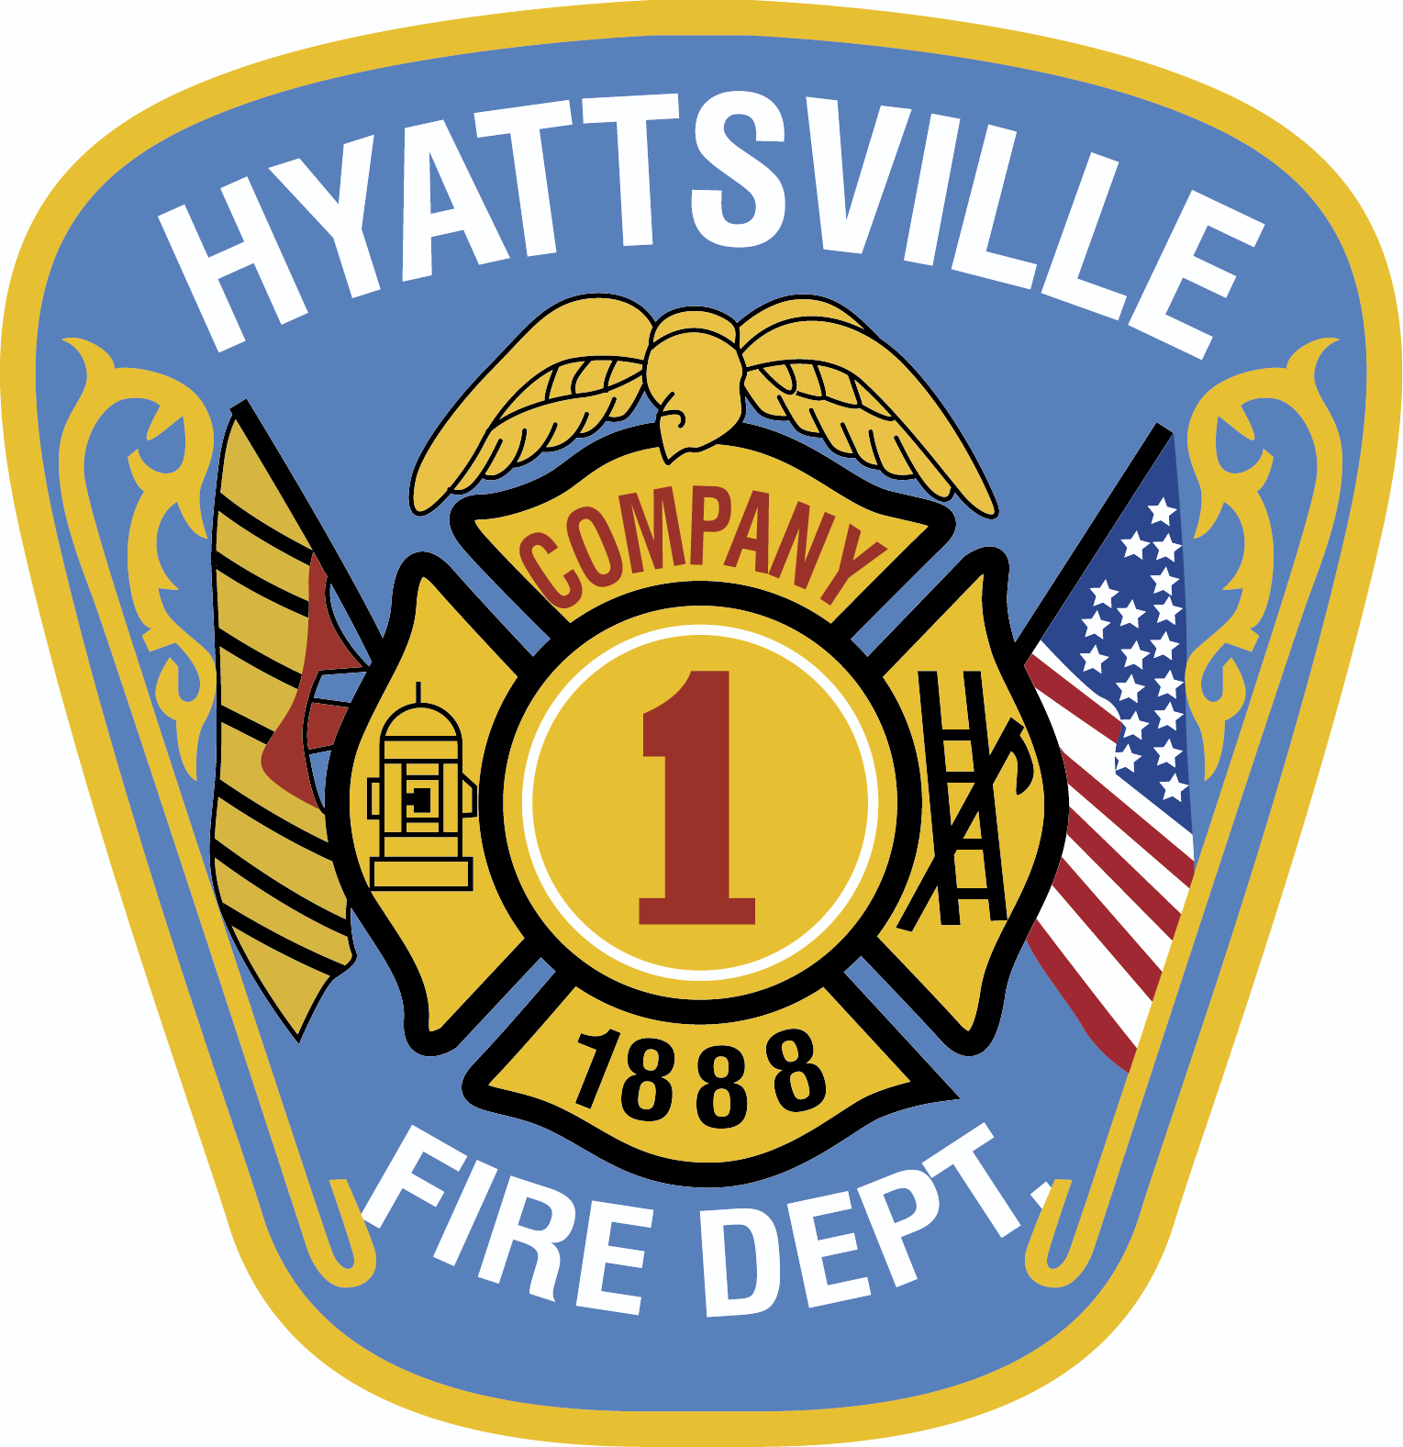
Hyattsville Volunteer Fire Department, Inc.
6200 Belcrest Road – Hyattsville, Maryland 20782
www.hvfd.com join@hvfd.com

NOTARY LOCATIONS

The following are locations that provide notary services necessary to complete the form, Authorization for Release of Personal Information (PG Form #4564):

- Wells Fargo, Riverdale Park
6235 Baltimore Avenue, Riverdale, MD 20737
(301) 277-1271
Lobby Hours:
Mon – Thu 09:00AM – 05:00PM
Fri 09:00AM – 06:00PM
Sat 09:00AM – 02:00PM
Sun closed
Call for availability and fees.

- The UPS Store
4423 Lehigh Road
College Park, MD 20740
(301) 699-0191
Call the store for availability and fees.

- Loredo Enterprises, LLC
5612 31st Avenue
Hyattsville, MD 20782
(240) 688-3511
(240) 645-2254
Office Hours:
Monday – Sunday 10:00AM – 07:30PM
Fee $6-$10 Call for availability and any additional fees.

